**HTML**

<div style="display:flex;">

<div class="pokemon">

<div class="img-container">

<img src="<https://raw.githubusercontent.com/PokeAPI/sprites/master/sprites/pokemon/2.png>"" alt="${name}">

</div>

<div class="info">

<span class="number">#2</span>

<h3 class="name">Babausaur</h3>

<small class="type">Type: <span>fire</span> </small>

</div>

</div>

<div>

**Using HTML only**

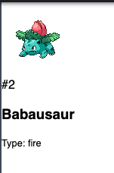

**Using HTML and CSS**

